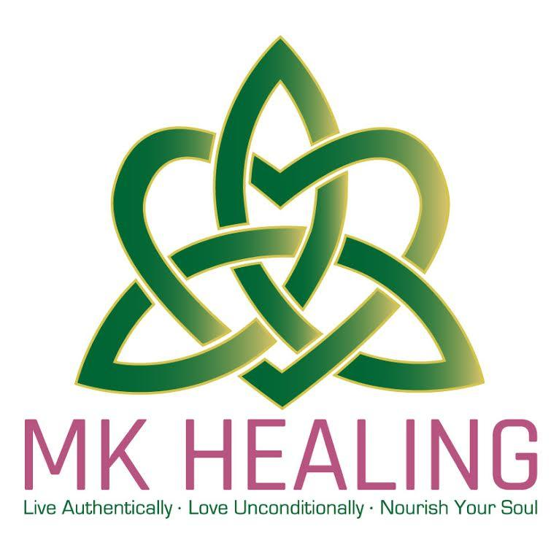

Informed Consent/Hold Harmless Agreement for Treatments, Classes & Events

I _____________________________ understand that Energy Healing/Soul Illumination Healing are complementary healing modalities that in no way substitutes for medical interventions, body therapy, or psychotherapy. I also understand that the Healing Practitioner may make suggestions for self-care as well as appropriate referrals.

I acknowledge that an open communication is promoted between me and my Healing Practitioner to enhance a mutual understanding and acceptance of the energy work provided during the treatment setting.

I further understand that there are numerous benefits possible through Energy Healing/Soul Illumination Healing, such as diminished pain sensation, increased relaxation, relief from anxiety and enhanced sense of well-being. These effects may vary depending on each individual’s response patterns. Although there are no known harmful effects from this type of intervention, I hold my Healing Practitioner harmless from any possible effects that may cause temporary physical or emotional discomfort and agree to take full responsibility for my self-care and personal development. I am in control of my own body and I can always “stop” at any time.

Signature: _____________________ Print Name: __________________________
Date: _________________________ Healing Practitioner: Mary Kate O’Connell__

